Creating Taks for the server auto power-off and power-on:
These are logic apps:
Go to azure portal---server name (VM)---taskcreate task
day is every day(week for every week(which date we can select that day it will take every week) particular day)
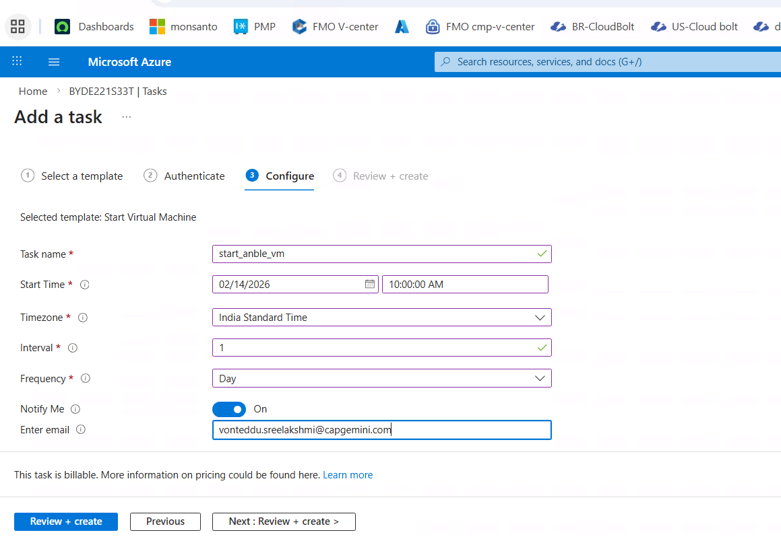

These are tasks created to stop and astart vm in azure(These are logic apps we can see in logic apps also and vmtasks)
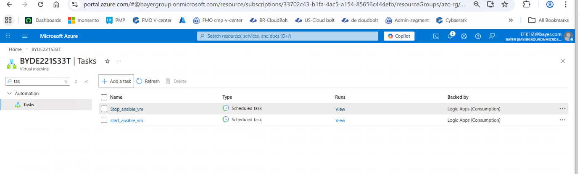
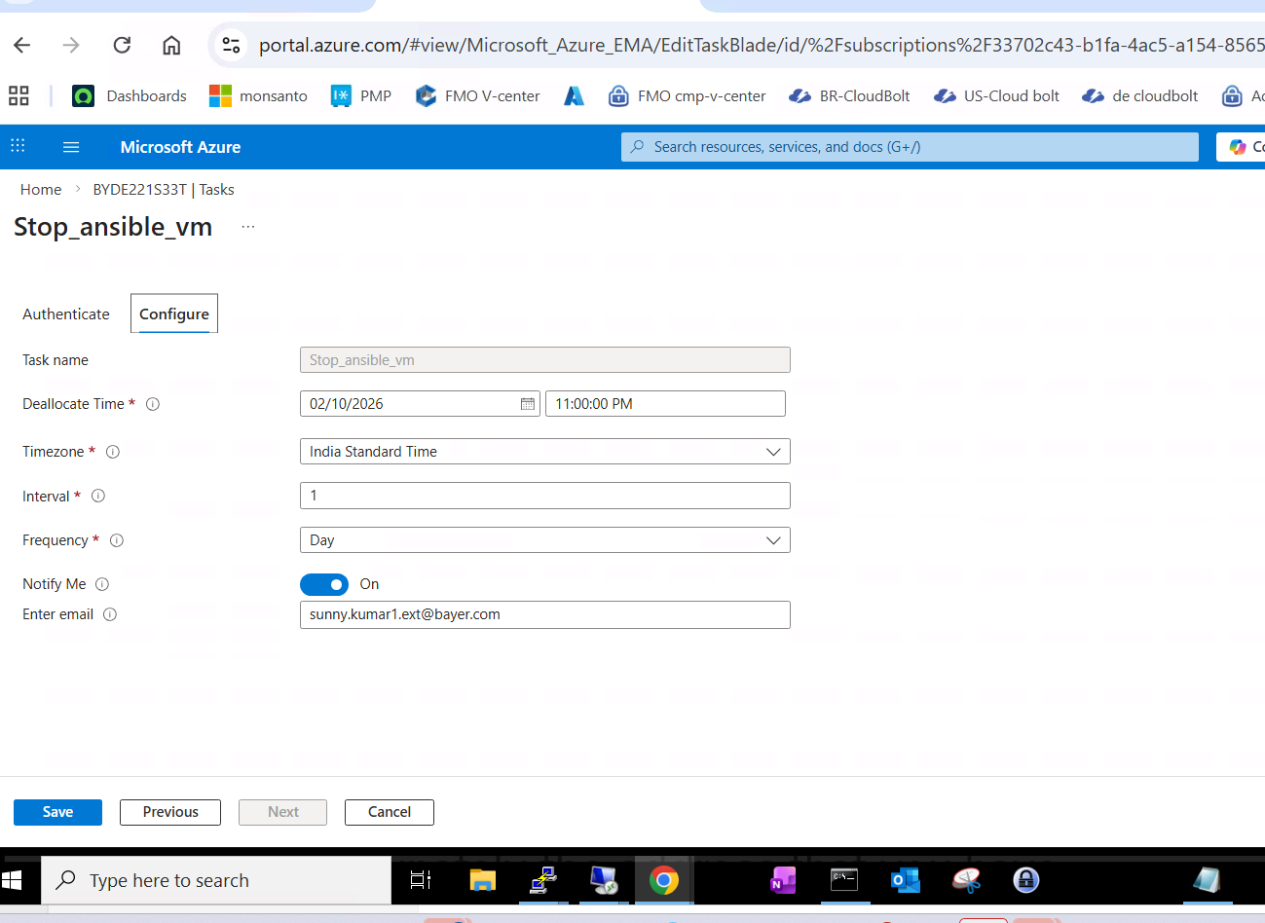==============================
it will take every monday
Else we can customise scripts also like below:
